No cost syndication to LeadingRE.com

We are pleased to announce we have acquired MLS data feeds to populate Leadingre.com at no cost, for over 350 MLS markets nationwide. This feed is provided by ListHub. Information about ListHub is available at www.ListHub.com.

Brokers in active MLS markets must Opt-in to begin sending their MLS listings to Leadingre.com. Only members of Leading Real Estate Companies of the World® have access to the "LeadingRE" option and must use a special code to see it.

The code is: RELO

How to Sign Up:

1. Visit [www.Listhub.com](http://www.Listhub.com)

2. Click the Login/Register icon on upper-right of the homepage



3. Choose “I am the head broker of record within the MLS” and click “Register Now”

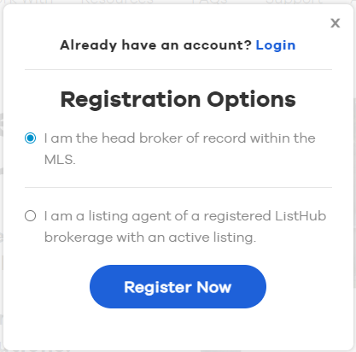

4. Complete the registration form with the required information, including the broker/office code you use in your MLS system, and click “Complete Registration”. You will then be logged into your account.

5. Click the gear next to your username in the upper right of the page and click “Settings”

6. Click on “Affiliate Codes”

7. Enter "RELO" in the box provided, and click "Submit"

8. Click on "Publishers” at the top of the page. You should see “LeadingRE” in the list of publishers in the “My Publishers” tab. You may also select any other site(s) where you would like to send your listings in the “Publisher Choices” tab.

9. It typically takes about 2-3 business days for our team to configure new broker accounts. It may take another 48 hours for your listings to appear on your selected sites.

10. Listing information will be kept up-to-date from the MLS daily.

11. Repeat the process above for each MLS that you have listings with.

*\*\*You must have an individual ListHub account for each MLS that you are listing through*

Need Help? Contact ListHub Customer Care: 877-560-0171 or CustomerCare@ListHub.com Or, from within your ListHub dashboard, click the "support" link on the upper right side of the page to submit a request online.